

Voyager Search

User Guide

Version 1.9.3

**Table of Contents**

Introduction 4

What is Voyager? 4

How Does Voyager Work? 4

Collectively Searches all Content 4

Creates a single index (catalog) 4

What Can Voyager Do? 4

The Voyager Interface 6

Searching for Data 7

Filtering Data 7

Searching by Area 7

Searching with Text 8

Boolean Searches 8

Searching by Field 9

Searching by Path 9

Searching with Wildcards 9

Escaping Special Characters 10

Sorting Search Results 10

Viewing Search Results 11

Summary View 11

Grid View 11

Map View 12

Table View 12

Report View 14

Configuring Views 14

Configuring Filters 14

Configuring the Display 15

Displaying Metadata on the Detail Page 15

Viewing All Metadata 16

Configuring Tables 17

Configuring Reports 18

Configuring Sorting 18

Viewing Information for a Single Item 18

Show Detail Page 19

Show Preview 19

Open With 19

Process 19

ArcGIS Online 19

Extent 19

Exclude Item 20

Saving Searches 20

Configuring the Default Search for all Users 20

Processing Search Results 21

Choosing a Task 21

Entering Task Details 22

Add to Geodatabase 22

Clip Data 23

Convert to KML 24

Copy Files 24

Create an Esri Map or Layer Package 25

Create GeoPDF 25

Mosaic 26

Mosaic to Workspace 27

Replace Workspace Path 27

Zip Files 28

Working with Lists 28

Adding Results to a List 28

Exporting Results as a List 28

Introduction

What is Voyager?

Voyager is a powerful search solution that combines a comprehensive knowledge of geospatial data with web style search.

With Voyager, users can easily find GIS datasets, images, maps, layers and other documents (Word, PowerPoint, PDF) stored on their desktop, on servers or on the web. This can greatly reduce the time users need to spend searching for information.

How Does Voyager Work?

Voyager runs as a server-based solution, accessed through any web browser. In both configurations Voyager fits within existing workflows and IT environments through an easy to install and easy to configure interface.

Collectively Searches all Content

Voyager provides the ability to search all geo-spatial content in an enterprise, although content sources might reside in different locations such as on a desktop, network file server, corporate database servers or web servers running internally or on the World Wide Web. All of the data appear as a single, integrated set of search results.

Creates a single index (catalog)

Voyager builds a comprehensive catalog of resources regardless of where data is stored, and does not require metadata or any system downtime. The catalog created by Voyager does not create a copy of the data, it simply finds it, makes a record of what it finds, and displays everything in a clean, easy to use interface.

Once the catalog is created users can search for content using text, spatial and filtered queries.

What Can Voyager Do?

Voyager’s universal search openly integrates data from anywhere in the organization using a single search solution. With Voyager you can:

Quickly index GIS data, maps and office formats (PDF, Word, and Excel etc.) on your own computer or across enterprise servers

Search for data and maps using full text and spatial queries as easily as you search the web

Immediately preview the results of your search through thumbnails and instantly use your selected items in a variety of GIS applications

Use search results in daily tasks such as adding data to ArcMap, extracting data to share with colleagues or use in the field, editing metadata, converting search results to KML, etc.

Voyager allows you to index and then search all of your GIS resources whether they are on your local file system, network shares or across the Internet. Once content is indexed, voyager streamlines a variety of daily tasks.

For people who are not familiar with specialized GIS software or simply have data in a variety of places, Voyager is the perfect solution for providing information on maps, datasets and GIS services when you want it – right on your desktop. Voyager improves productivity by providing easy access to all of your GIS resources.

Voyager makes publishing a searchable index of available GIS resources within a team, across an organization or over the Internet as easy as a single step. With Voyager you can quickly index and publish the maps and datasets that you wish to share. Voyager serves as a GIS portal.

Voyager creates a rich, searchable index by crawling your datasets, layers, maps and GIS services. It is because of this that Voyager surpasses traditional GIS portals by offering a richer index by including items which traditional portals ignore such as map layers and map documents. Voyagers modern search interface is easy to use and makes searching your organization’s GIS resources as easy as searching the web.

Voyager helps answer

* How many datasets do I have?
* How many duplicate datasets are there?
* Which datasets are large? Which are small?
* What spatial references am I using?
* Which datasets are most commonly used in my maps?
* Which resources are slow to access? Slow to draw?

All of these questions can be answered within the search window. Searches can be saved and then re-run or shared with other users. Search results can also be viewed as RSS feeds enabling you to be updated as changes occur.

The Voyager Interface

The Voyager display is composed of a few basic components, including a textual search box, a toolbar containing some helpful menus, a search results area, an overview map, and filters, all of which will be explained in this section.

**Overview Map**

**Search Box**

**Filters**

**Search**

**Results**

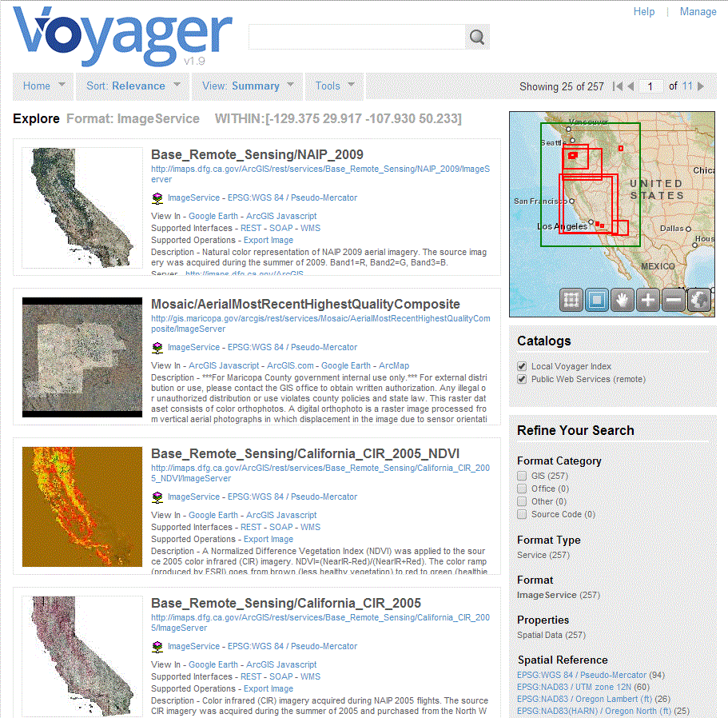

Searching for Data

Searching for data can be done in different ways. Voyager provides filters, which can be used to narrow your set of results to just the data you are looking for. Another option is to do a textual search using the search box. You can also search by selecting an area from the Overview Map.

Filtering Data

Below the Overview Map is a list of Filters, which are used to refine a search. Within the Filters section, Field Statistics shows the total size, average size, and deviation for all files in the index. See **Configuring Filters** for information on how to customize the filters.

Searching by Area

By default, Voyager displays all of the search results on the Overview Map. To search an area (extent), click and drag a rectangle on the map. Voyager will display search results for that area. The green lines outline the search extent and the red lines show the results within that extent.

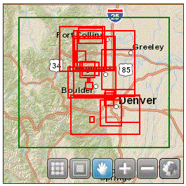

The map has the following controls (the selected control will be highlighted):

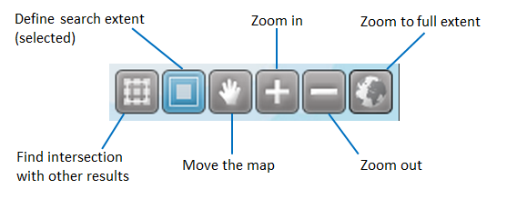

Searching with Text

Use the search box for text queries. By default, Voyager searches over all text (including metadata) for matching items. Results that match the title or path are ranked above results matching any other text.

Boolean Searches

Voyager supports the Boolean operators **AND** and **OR**.

**OR**

The OR operator is the default search operator. This means that if there is no operator between two terms in a search, the OR operator is used. The OR operator links two terms and finds a matching document if either of the terms exist in a document.

**EXAMPLE:** to search for documents that contain either "Florida highways" or just "highways" use the query:

"Florida highways" highways

or

"Florida highways" OR highways

**AND**

The AND operator matches documents where both terms exist anywhere in the text of a single document.

**EXAMPLE:** to search for documents that contain "rivers" and "lakes" use the query:

rivers AND lakes

Searching by Field

When performing a search you can either specify a field name, or use the default search, which uses many fields. You can search any field by typing the field name in lowercase followed by a colon ":" and then the term you are looking for.

Searching by field names only produces results that match the particular field specified. For example, to search for any documents with "Rivers" in the name field and "Florida" in the path field, use the query:

name:rivers AND path:Florida

**Note**: The field is only valid for the term that it directly precedes, so the query

name:major cities

Will only find "major" in the name field. It will find "cities" using the default search which uses many fields.

To search for 2 or more terms in a field name, quotes around the text are required.

**EXAMPLE:** to search the name field for "major cities", use the query:

name:"major cities"

Searching by Path

Paths in Voyager can either be searched for using the standard field selection operator ":", or a special "=" operator that matches folders explicitly.

**EXAMPLE:** Using the standard "path:" syntax, the query is looking for words in the path.

path:Desktop

Will return items with "Desktop" in the path.

**EXAMPLE:** Using the "=" operator will find files explicitly in a folder. For example:

path=F:\Desktop\NJ DEP\NJ100mhillshd\nj100mhill

Will find all results under this folder. Aditionally, the **path=** syntax triggers a special [Path Navigation](http://voyagergis.com/doc/current/all#1573698) UI.

Searching with Wildcards

Voyager supports single and multiple character wildcard searches within single terms.

* To perform a single character wildcard search use the "?" symbol.
* To perform a multiple character wildcard search use the "*" symbol

The single character wildcard search looks for terms that match that with the single character replaced.

**EXAMPLE:** To search for "text" or "test" you can use the search

te?t

Multiple character wildcard searches looks for 0 or more characters. For example, to search for counties or countries, you can use the search:

count\*

Escaping Special Characters

Voyager supports escaping special characters that are part of the query syntax. The current list special characters are:

+ - && \|\| \! ( ) { } \[ \] ^ " ~ * ? :

To escape these character use the \ before the character.

**EXAMPLE:** To search for (1+1):2 use the query:

\(1\+1\)\:2

Sorting Search Results

The Sort tab has a list of sorting options so you can see results in the way that makes most sense to you.  To change sorting options, select **Configure Sort** from the **Settings** options under the **View** menu.

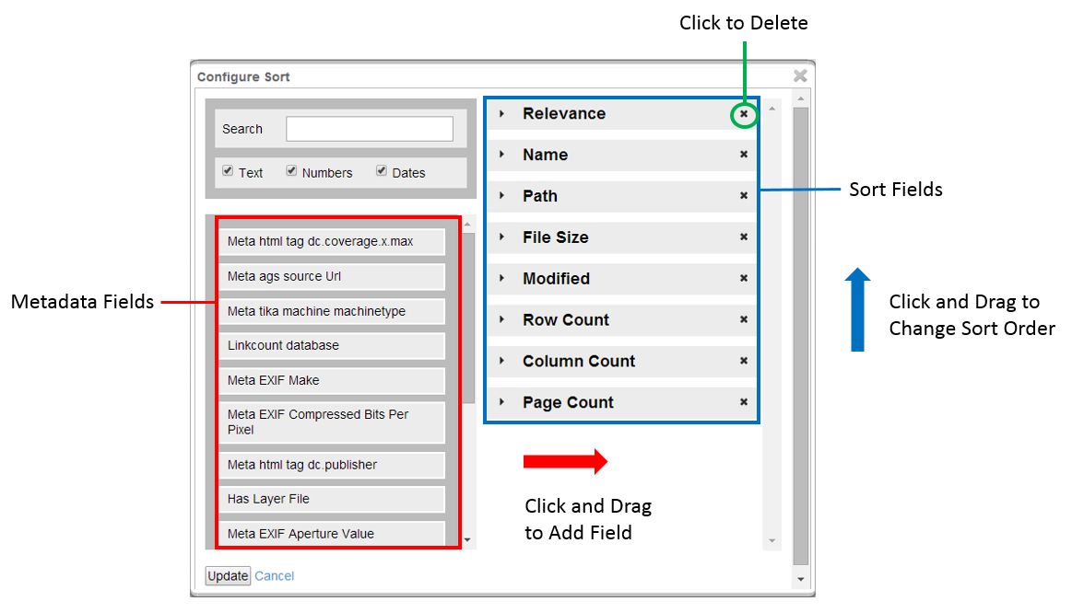

Viewing Search Results

Once your index is created, you can view the items in the index in various ways, allowing you to visualize your information in the most appropriate way. Views are used to display the data in a layout of your choice (Summary View, Grid View, Overview Map, Table View, or Report View), with a configurable set of fields displayed and providing a useful set of filters for further refining your queries.

Summary View

The summary view displays a few pieces of information about each item, along with the thumbnail for the item.

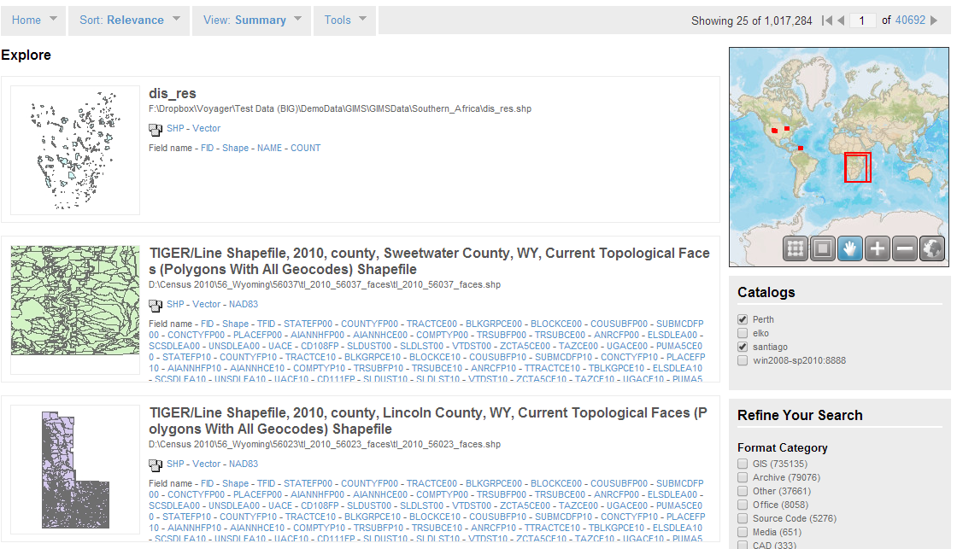

Grid View

The grid view displays each item as a thumbnail only. When you hover over a thumbnail, more information about that item is displayed.

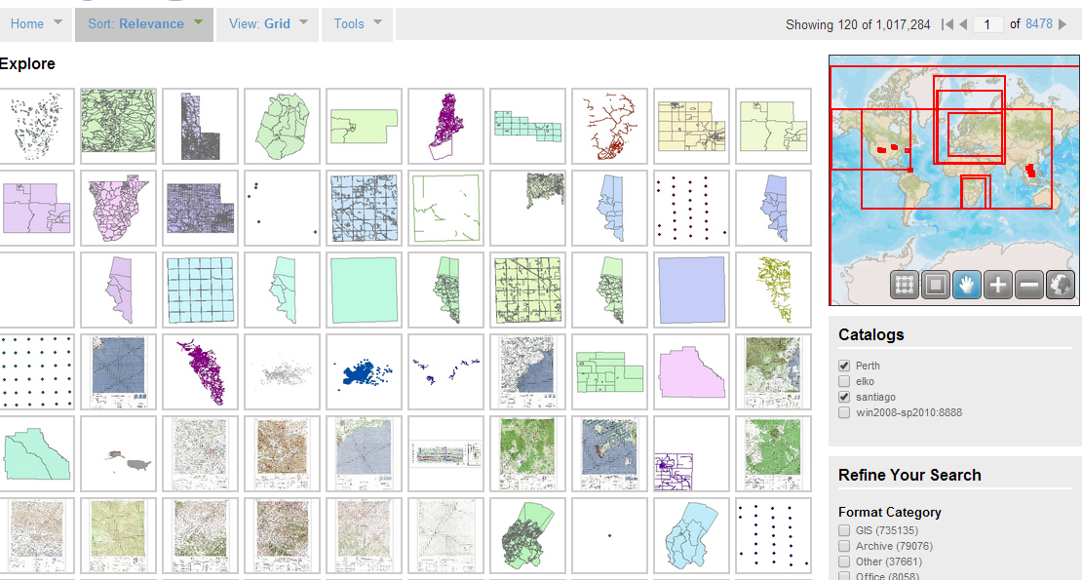

Map View

The map view displays the relationship between the data and where it lies spatially.

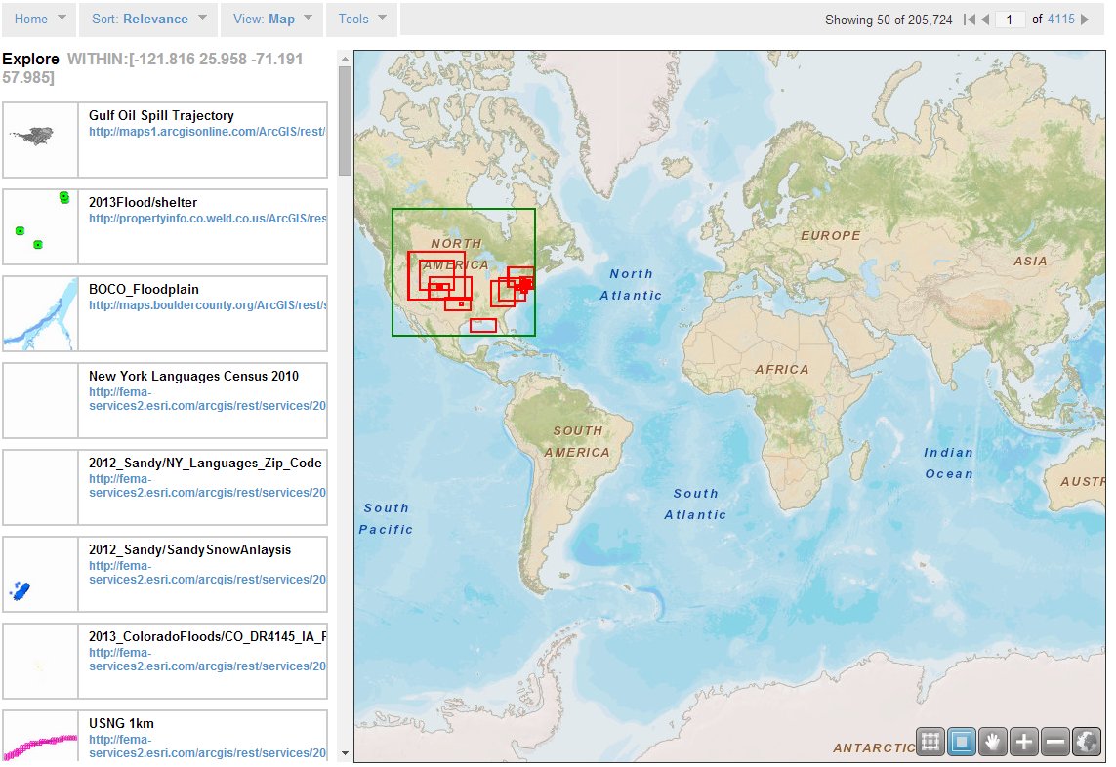

Table View

The table view displays results as a list. This is useful for comparing results based on a property, such as the size of the item in Bytes or the time it took to index the item.

To configure which fields shown in the table, see Configure Table

**Tip:** When displaying results in the Table View a user has the ability to export the result list in CSV, SHP or XML. This option is offered at the bottom of the page.

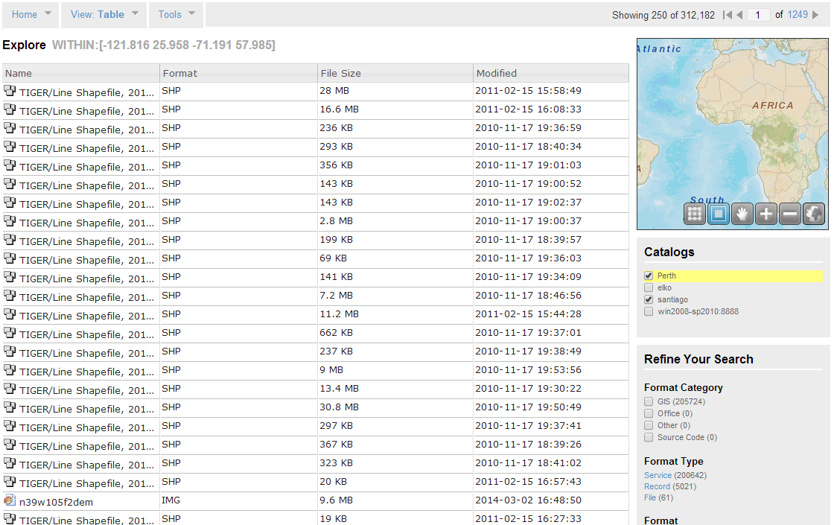

Report View

The report view that generates graphs based on the configurable set of filters used to narrow search results. Graphs include pie and bar charts, are interactive and will work in any web browser.

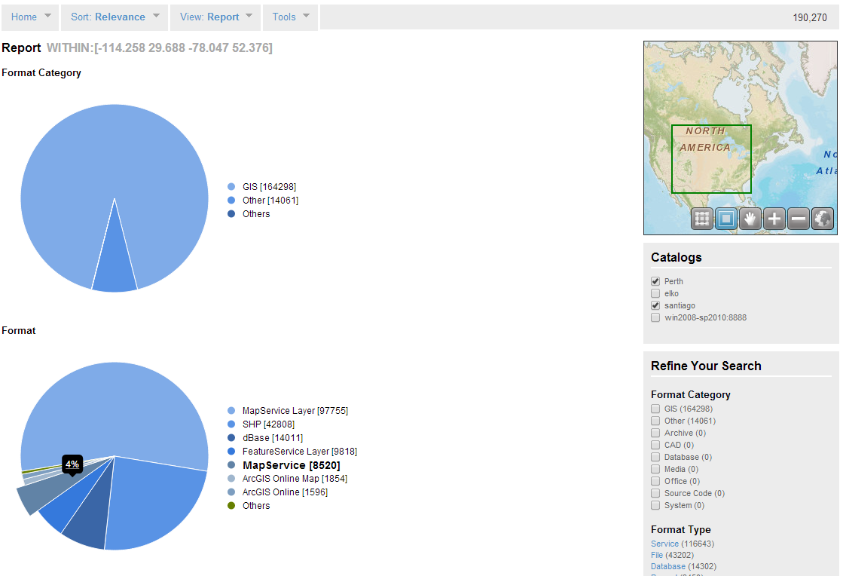

Configuring Views

Views are fully configurable, allowing you to change the filters, reports, sort, display, and table options.  Any user with the *configure_views* permission can create custom views. To configure views, select **Settings** under the **View** menu. You can choose to configure

* Filters
* Display
* Tables
* Reports
* Sorting

Configuring Filters

This option allows the user to select fields that will be used to filter query results. The filters are used to show a subset of the data, giving the user a better idea of the types of data in the index and to narrow down exactly what they may be searching for.

Additional filters can be added from the set of Fields on the left, or filters can be removed from the active Filters list by using the left/right arrow buttons in the middle of the window to move things into and out of the list. The display order the filters can also be changed using the up/down arrow buttons.

To view data from both local and remote catalogs, select the **Show Additional Catalogs** option. Remote catalogs must have been previously configured by the administrator. See Federated Catalog Search.

Configuring the Display

You can configure which metadata fields Voyager displays on the **Detail Page** as well as in the **Table View**.

Displaying Metadata on the Detail Page

To configure metadata display on the **Detail Page**:

1. Go to **View -> Settings -> Configure Display** on the **Summary** page

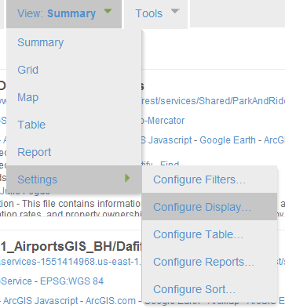

1. On the **Fields** and **Name** tabs, you can drag and drop fields from the left side to the list on the right

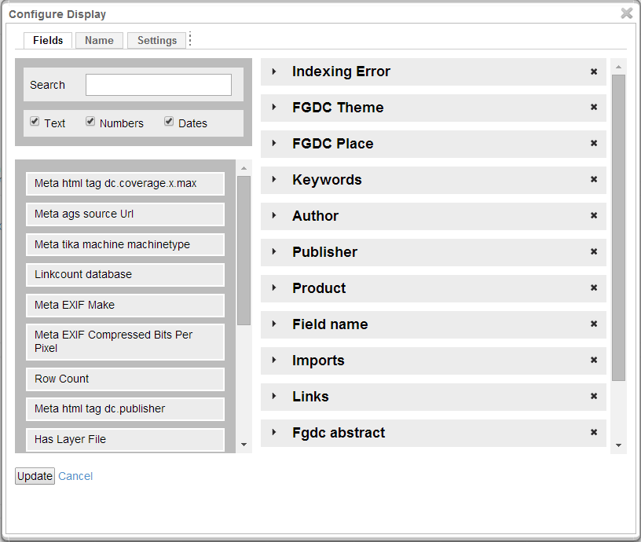

1. Click **Update** to apply your changes.

The added fields will appear on the **Detail page**. Some of the fields may also appear in the **Summary** **View**, when hovering in **Grid** **View** and in **Map** **View**.

Viewing All Metadata

1. To view all metadata for a record, go to **View -> Settings -> Configure Display Settings**

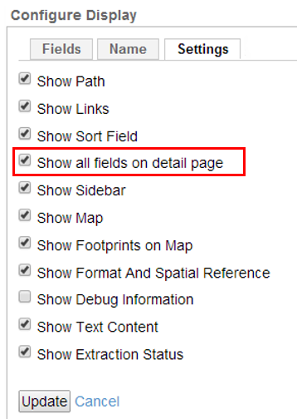

1. Select **Show all fields on Detail Page** to display all metadata fields on each Detail Page
2. When you are done, click **Update**

Configuring Tables

You can choose which metadata fields appear in the **Table View**. Each field you choose appears as a column in the table.

1. To configure tables, go to **View -> Settings -> Configure Table**

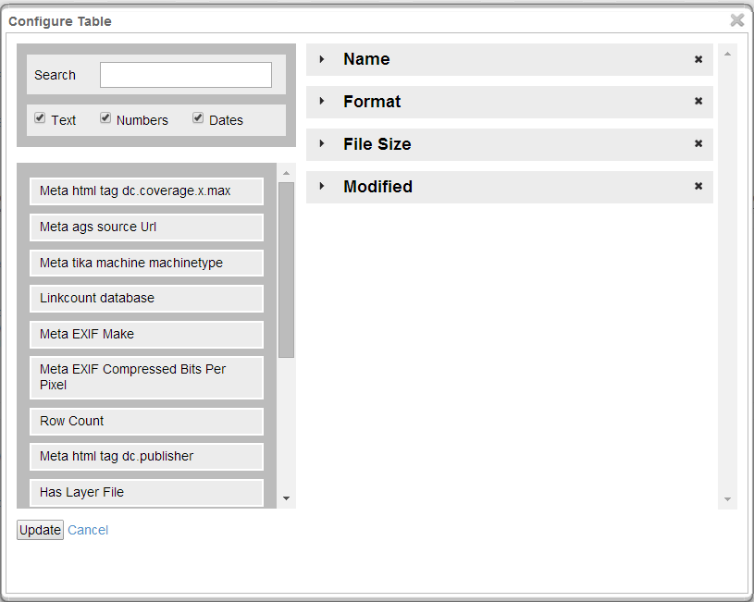

1. Drag and drop field names from the list at the left over to the right. The field columns will be added to the **Table View** even if there are no data for that particular field.
2. To change the order in which the fields are displayed, click and drag fields up or down in the list at the right
3. Click **Update** when you are done

Configuring Reports

The reporting view displays a graph for each of the fields used to filter query results (as seen on the right side of the Voyager interface). To hide or remove a report the appropriate field can be added or removed from the list of filters.

Configuring Sorting

This option allows a user to choose which fields are available for sorting query results.

You can add or remove display fields, or change their display order using the arrow buttons in the middle of the window.

Viewing Information for a Single Item

Voyager provides options to a user when a thumbnail of an individual search result is clicked in the Summary, Grid or Map Views.  The Overview Map to the right of Search Results displays the extents of the data on a map.

Show Detail Page

The Detail Page reveals many more information about this individual element. By default, the details displayed include basic attributes like the name, path, theme, place, etc. What information is displayed can be configured via the Configure Display option under the View menu.

The detail page also shows links or relationships between the item and any other items in the index.  For example, if the dataset is used in an MXD or Layer File, the MXDs or Layer Files will be displayed as links in the "USED BY" section.

Conversely, MXDs and Layer Files display the items within them in a tree structure, so users can see which Feature Layers and datasets are used in the document and can explore them directly from the DATA section or via the links in the MXD structure.

The relationships between items in a database are also captured and displayed. For example, databases show links to all of the items within them. Feature datasets show which database they are in, as well as the datasets they contain. And datasets have links to their database and feature datasets.

Show Preview

Show Preview displays a larger, more detailed view of the record if it exists.

Open With

The **Open With** option allows the user to open the individual search result in a variety of desktop applications, including ArcGIS desktop applications, KML viewer, or the Window Default Application.

Process

This option opens the choices for processing the individual search result.

ArcGIS Online

The individual search result can be added to ArcGIS online.

Extent

This gives the user the options to:

* **Zoom to Extent** - Zooms the map into the extent of this item
* **Query Within Extent** - Performs a spatial query and returns all items whose extent falls completely within the current item's extent.
* **Query Extent Intersection** - Performs a spatial query and returns all items whose extent intersects the current item's extent.

All results are reflected in the overview map in the upper right-hand corner of the window.

Exclude Item

This option allows the user to exclude an individual search result from the search.

Saving Searches

This tool allows a user to save their search result and use it as the default search. For a complete list of your saved searches, go to the **Saved Searches** page from the Home menu.

Configuring the Default Search for all Users

A default search can be configured and saved, so all users will see the same filters, display fields, table layout, and default view.

* To create a default search, go to the **Tools** menu and select **Save This Search**.  Enter a Title and Description for the search and select the **Use As Default** **Search** option.
* To set the default search to a Saved Search that was previously configured, go to the Saved Searches page and on the **Options** menu select **Show Edit Options**.  Edit any of the existing Saved Searches and select the **Use As Default Search** option.

Processing Search Results

Choosing a Task

You can select one or more search results and save or convert them to various formats. Once you have selected the results, go to **Tools > Process** to open the **Task Manager** and select one of the following tasks:

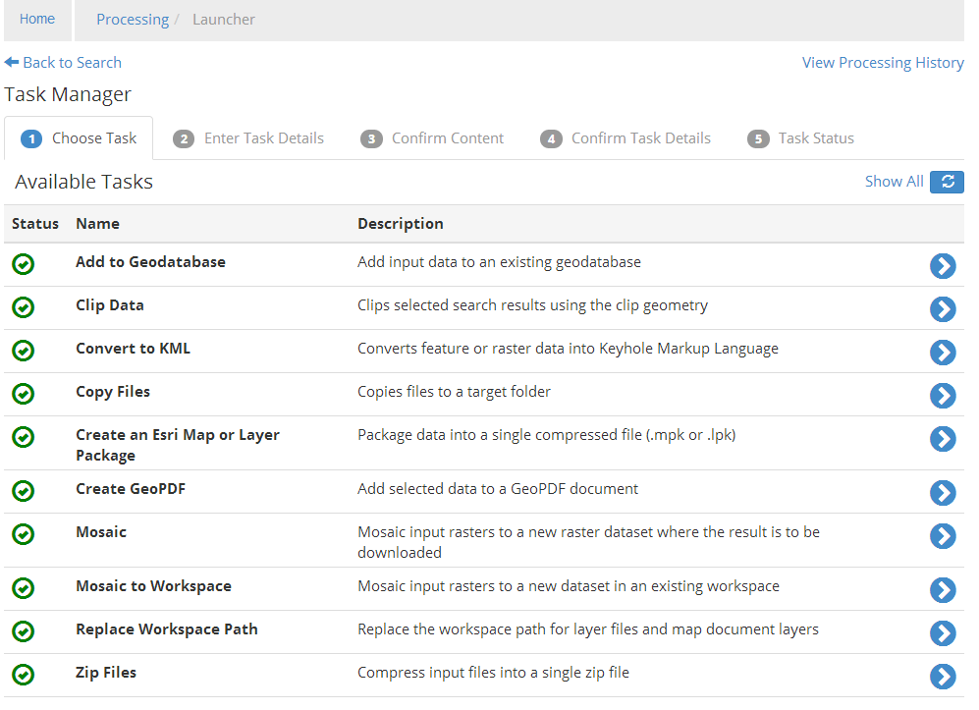

For each of the selections in the list, enter the required data and configuration information and confirm each step of the process before moving on to the next. The particular information needed depends on the processing task you choose.

In the **Task Manager**, current and previous steps are shown in blue; yet-to-be-completed steps are shown in gray.



There are five steps for each task. You can return to a previous step or select a different task at any time.

1. **Choose Task**  
   Choose a task from the list in the **Task Manager.**
2. **Enter Task Details**   
   Enter the required information for the task you have chosen.
3. **Confirm Content**  
   Voyager displays the selected content. You can remove an item here and go back to the previous step to select different input information.
4. **Confirm Task Details**  
   This displays the content and the task information you selected. Click Run Task to process the content.
5. **Task Status**  
   This displays the status of the task, including any error messages.

Entering Task Details

Enter information for tasks in the **Enter Task Details** tab as described below.

Add to Geodatabase

Adds input data to an existing geodatabase.

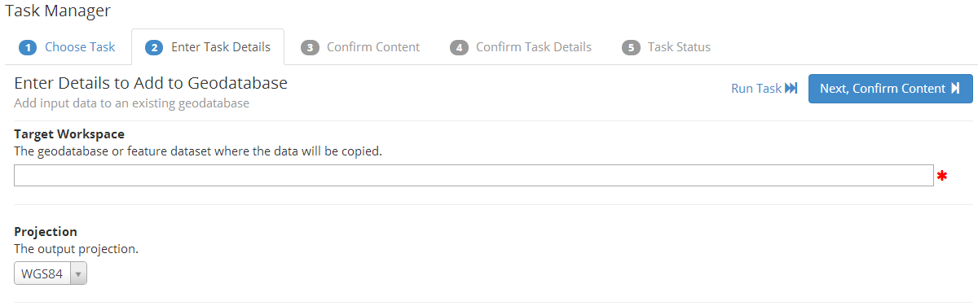

* Enter the target database or dataset and select an output projection
* Click **Next** to go to the **Confirm Content** tab

Clip Data

Clips selected search results using the clip geometry.

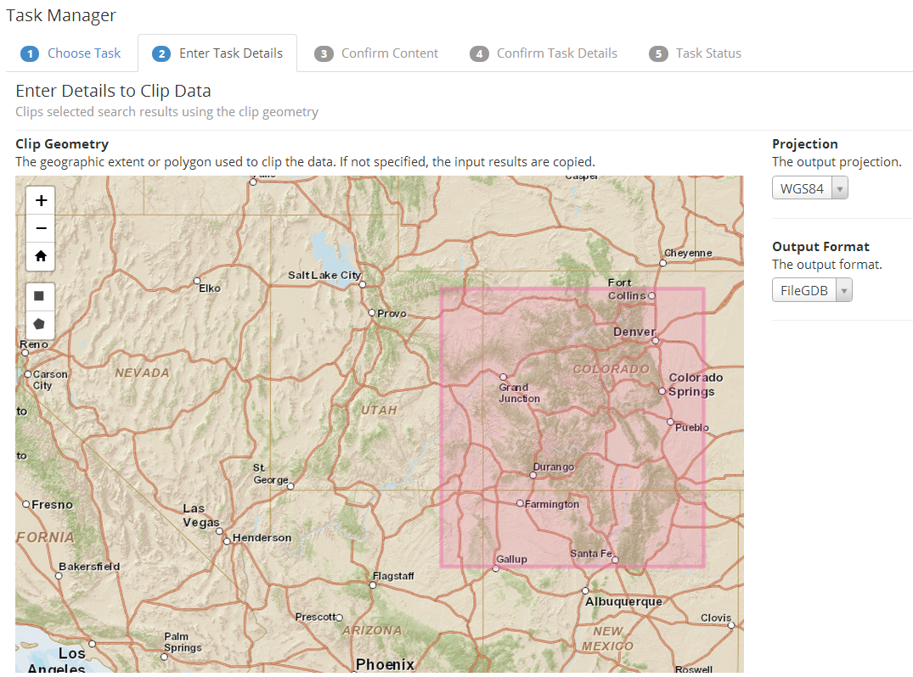

* Select whether to clip a rectangle or polygon:

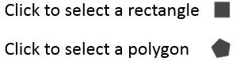

* For a rectangle, click and drag to select an extent on the map
* For a polygon, click the points that outline the desired extent and double-click to select the area
* When you have selected an area, choose an output format and projection
* Click **Next** to go to the **Confirm Content** tab

Convert to KML

Converts feature or raster data into Keyhole Markup Language.

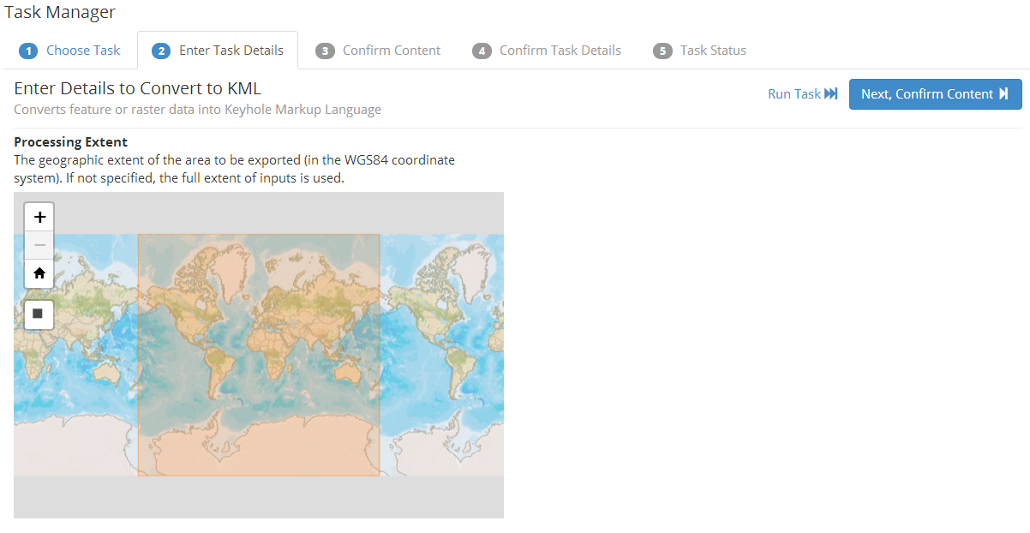

* Click and drag on the map to select an extent
* Click **Next** to go to the **Confirm Content** tab

Copy Files

Copies files to a target folder.

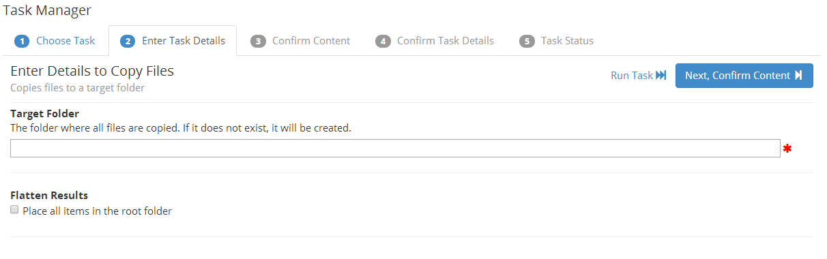

* Enter the location of the target folder
* Click **Flatten Results** to copy all results into the target folder
* Click **Next** to go to the **Confirm Content** tab

Create an Esri Map or Layer Package

Packages data into a single compressed file (.mpk or .lpk)

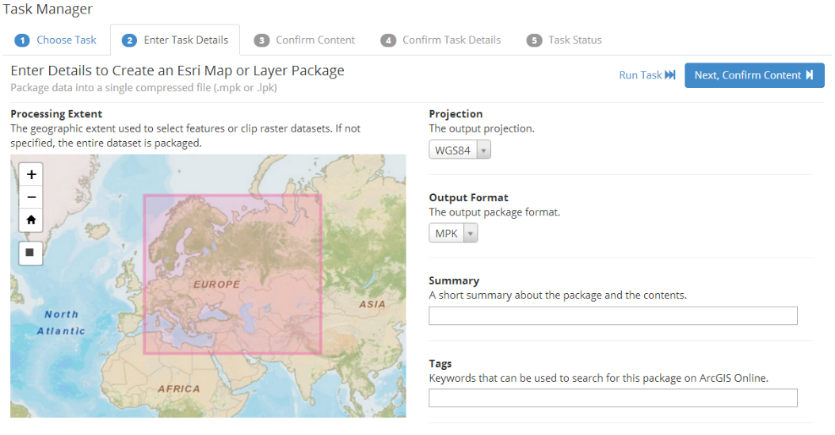

* Select projection and output format
* Enter a descriptive summary
* Enter any tags you want to associate with the selection
* Click **Next** to go to the **Confirm Content** tab

Create GeoPDF

Adds selected data to a GeoPDF document.

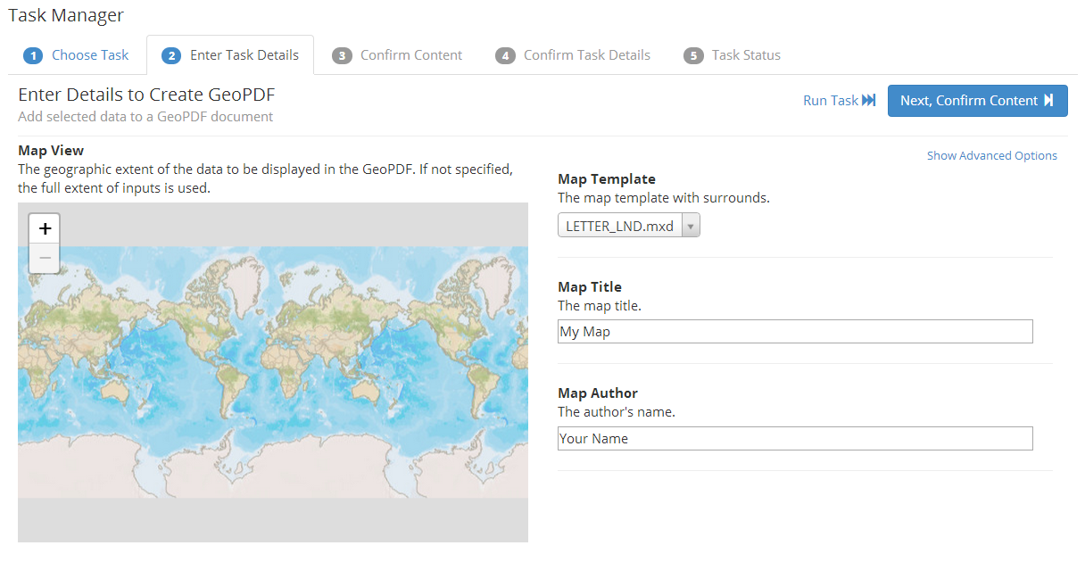

* Enter a map template, map title and map author
* Click **Next** to go to the **Confirm Content** tab

Mosaic

Mosaics input rasters to a new raster dataset where the result will be downloaded.

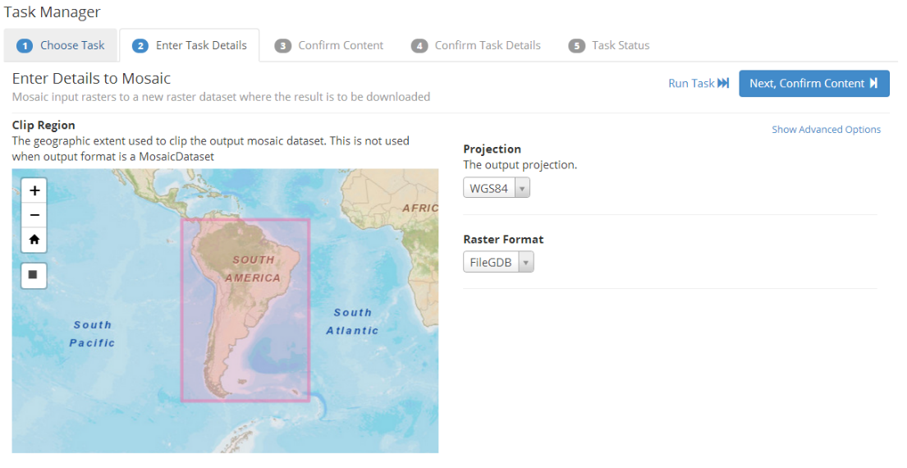

* Click and drag to select a region
* Choose the output projection and raster format
* Click **Next** to go to the **Confirm Content** tab

Mosaic to Workspace

Mosaics input rasters to a new dataset in an existing workspace.

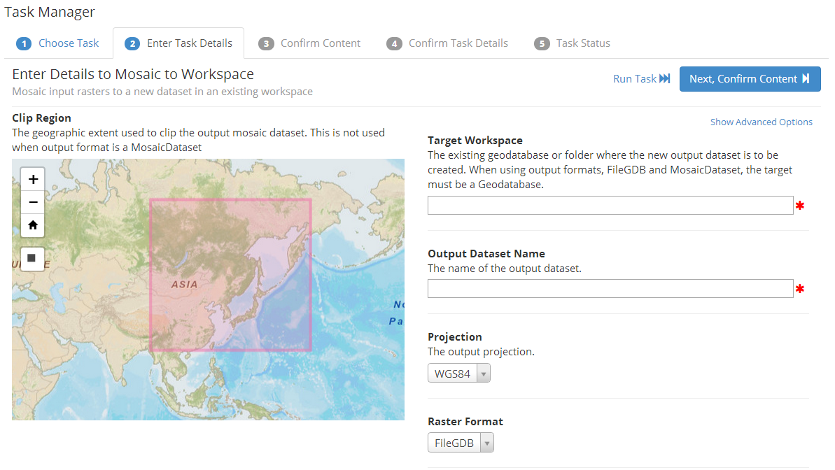

* Enter the geodatabase or folder target
* Enter a name for the output dataset
* Choose a projection and raster format
* Click **Next** to go to the **Confirm Content** tab

Replace Workspace Path

Replaces the workspace path for layer files and map document layers.

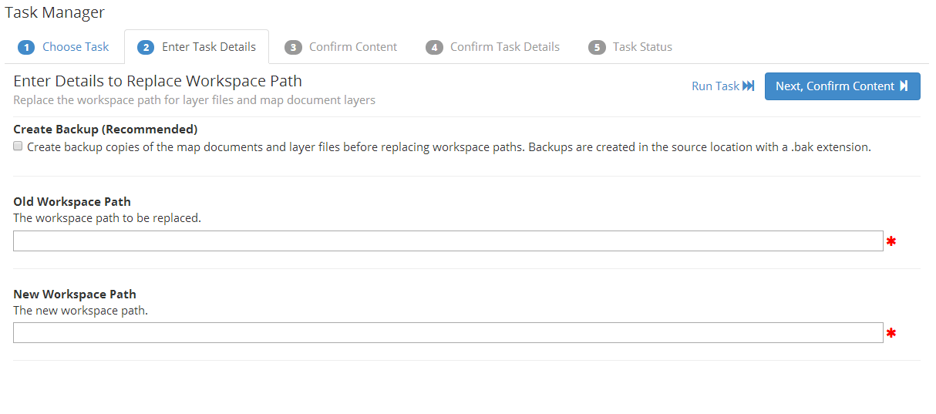

* Enter the existing workspace path
* Enter the new workspace path
* Check the box to backup the workspace
* Click **Next** to go to the **Confirm Content** tab

Zip Files

Compresses input files into a single zip file.

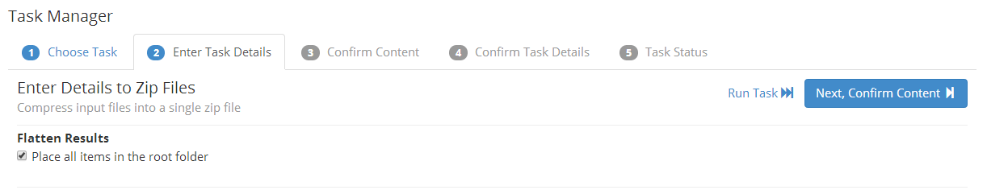

* Select Flatten Results to place all files in the root folder
* Click **Next** to go to the **Confirm Content** tab

Working with Lists

Lists hold search results that can be used at a later time, much like a shopping cart in an online store. This gives a user the option of either adding their data search results to an existing list or creating a new list. Lists are useful when you are building up a set of data that you want to do something with later on (much like adding things to a shopping cart).  Once a list has been created, all the results in that list can be run through one of the processes, opened in ArcMap, exported to a CSV file, etc.

Adding Results to a List

* To add a single search result to a list, click the thumbnail and select **Show Detail Page**. On the Detail page, select **Add to List** from the **Tools** menu.
* To add all search results, select **Add to List** from the **Tools** menu on the Home page. You can add a maximum of 250 items at a time.

Exporting Results as a List

To export the list, select **Export Results List** from the **Tools** menu on the Home page or on the Detail page. This allows the user to export the list of results to different formats, including CSV, XML, or even to a Shapefile. The fields that will be exported to the list are configurable. A few default fields have been set: id, name, path, and format. The user can choose other fields that make sense, or remove any of the default fields using the left/right arrow buttons in the middle of the dialog. The order of the fields can also be changed using the up/down arrow buttons. The user also has the option of adding the output to a zip file when it is complete.